THEORY
Positions of the feet: 1st 2nd 3rd 4th 5th
Positions of the head: Erect (Straight), Turned (Turn the head to either side), Inclined (Tilt the head to either side), Raised (Look at the roof) & Lowered (Look at the floor)
Positions of the Arms: 5th en bas [5th on bar] - Low
5th en avant [5th on ah-vont] – In front
5th en haut [5th on ‘O’] - High
Movements in Dancing: Plié to Bend [Pronounced: Plee-ay]
Étendre to Stretch [Pronounced: Ay-tohn-dray]
Relevé to Rise [Pronounced: Rah-le-vay]
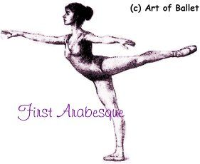
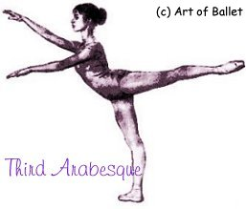
Arabesques [A-ra-besk]: Foot on the floor 1st Arabesque & 3rd Arabesque

Body Position: A la quatrième devant A la Seconde A la quatrième derriere [ka-tree-em]

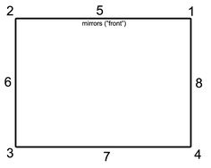
8 Points of the Room:

WORDS TO KNOW
Devant [duh-vahn]: Front
En Avant [on-avahn]: Forward
Derrière [deh-re-air]: Back
En Arrière [on a-re-air]: Backwards
Soutenu [soot-nu]: To show a stretch and a bend after a jump
De Suite [duh-sweet]: Continuous/series of jumps one after the other

STEPS TO KNOW
Sauté [soh-tay]: Jump in 1st position (Can be shown ‘Soutenu’ or ‘De Suite’)
Changements [shon-shmon]: Jump changing feet in 5th (Can be shown ‘Soutenu’ or ‘De Suite’)
Èchappé Sauté [ay-sha-pay soh-tay]: McDonalds ‘M’ in 5th position changing feet (Can be shown ‘Soutenu’ or ‘De Suite’)
Pas de Chat [par-duh-shah]: Jump from 5th position starting with the back foot (Can be shown ‘Soutenu’ or ‘De Suite’)
Assemblé [a-som-blay]: To assemble the legs together (Can be shown over or under ‘Soutenu’)
Pas de Bourrée under [par-duh-ber-ray]: start with the leg extended to the side. Behind, side, front
Balancé [balance-ay]: Shown sideways. Down, up, up.
Chassé en Avant to pointe tendu derriere: Bend, slide forwards, stretch and show a pointe behind
Chassé en Arriere to pointe tendu devant: Bend, slide backwards, stretch and show a pointe in front
Posé Coupé [Po-zay Coo-pay]: step up on one foot, then pointe that foot forward as you lower down on the other foot on a bend

